**Research Group on Manuscript Evidence   
2024 Anniversary Survey**

**Version as Word Document**Please send your completed response to[**rgme.surveys@gmail.com**](mailto:rgme.surveys@gmail.com)

Information: [2024 Anniversary Survey](https://manuscriptevidence.org/wpme/2024-anniversary-survey/).

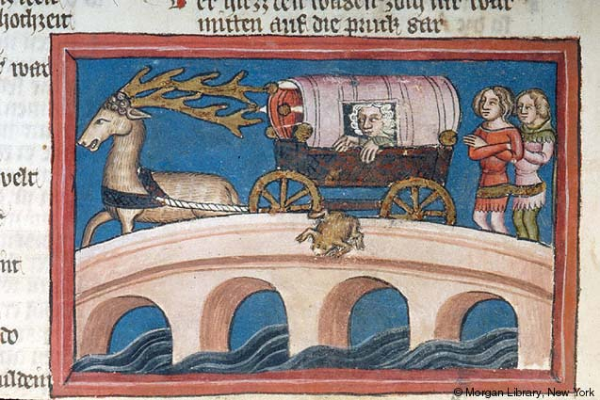

*Image.*New York, Morgan Library & Museum, MS M.769, fol. 305v, detail:   
Legend of Pregnancy with Frog (*Weltchronik* or World Chronicle, Regensburg, Germany, 1360).   
Image © Morgan Library, New York via <https://ica.themorgan.org/manuscript/page/215/143938> .

We invite you to fill out this short survey, to help us guide future activities of the [Research Group on Manuscript Evidence](https://manuscriptevidence.org/wpme/).  The results would aid us to learn about your interests and wishes as we:

1. launch the [Friends of the RGME](https://manuscriptevidence.org/wpme/friends-of-the-research-group-on-manuscript-evidence) to welcome our wider community;
2. prepare for our Anniversary Episode in September with “RGME Retrospect and Prospects ([Episode 17](https://manuscriptevidence.org/wpme/episode-17-rgme-history-impact-and-potential) of [“The Research Group Speaks”](https://manuscriptevidence.org/wpme/the-research-group-speaks-the-series)); and
3. assemble an **Anniversary Anthology** to celebrate our [2024 Anniversary Year](https://manuscriptevidence.org/wpme/bridges-for-our-2024-anniversary-year/) as part of our program of [RGME Publications](https://manuscriptevidence.org/wpme/profile/publications/).

We welcome your suggestions and feedback.  This Survey is designed to gather feedback for our in-house use, to guide our planning better attuned to our community. Respecting privacy and confidentiality, we might at some time report aggregate views from the Survey, but without giving names.

Please join our explorations of RGME identity, purpose, impact, and futures as we reflect on past accomplishments and explore new content ideas for the direction of future symposia, meetings, and publications.

* The survey should take less than ten minutes to complete.
* Please aim to complete the survey by **Wednesday, 18 September 2024 at midnight EDT (GMT-4)**, when its **First Round** will close.
* A chance to complete the Survey in a **Second Round** will remain open until **Sunday, 23 September 2024 at midnight EDT**, to give scope to offer feedback after **Episode 17**.

We are grateful for your time and input, and we thank you for your suggestions.

Please send your completed survey Word document attached to an emailto[**rgme.surveys@gmail.com**](mailto:rgme.surveys@gmail.com)with the heading “RGME 2024 Survey Response”; or addressed by mail to the RGME at 46 Snowden Lane, Princeton, New Jersey 08540, U.S.A.

**Question 1.** Please tell us your affiliation(s) and role(s) / position(s) (if not applicable, please write "independent"), as well as some of your topics of interest.

**Question** **2.** How did you initially find out about the RGME, and when? What drew you to it?

**Question 3.** How often do you participate in RGME-hosted events?

(rated on a scale of 1-5; 1 being Never, 5 being Always)

**Question** **4.** Would you see yourself participating more often if certain topics were covered more frequently? If so, what is an example of such?

**Question** **5.** Would you have an interest in speaking informally about your recollections of events or people of the RGME at [Episode 17](https://manuscriptevidence.org/wpme/episode-17-rgme-history-impact-and-potential) on **“RGME Retrospect and Prospects**” (21 September 2024 by Zoom)?

**Question** **6.** What have been some of your favorite individual RGME events? This may include sessions sponsored or co-sponsored by the RGME at conferences, as well as our own events, such as Symposia, whether in-person, online, or hybrid.  If you cannot remember the name, a recollection of the theme, topic, people, or occasion will do. Which ones worked especially well for the RGME? Why?

**Question** **7.** What would you consider some Landmark events or achievements of the RGME’s history?

**Question** **8.** How do you feel the actions and activities over the years have reflected the missions and goals laid out by the RGME?

**Question** **9.** Do you use/visit the RGME website (<https://manuscriptevidence.org/wpme/> )? If so, how often?

**Question** **10.** If so, what do you like about the RGME website? What could it do better? Suggestions or requests? Do you find the navigation and accessibility of the website to be difficult or easy?

**Question** **11.** Do you follow or visit our blog on “Manuscript Studies” (<https://manuscriptevidence.org/wpme/manusript-studies/> )? Do you have any favorite blogposts to recommend for our **Anniversary Anthology**?

**Question** **12.** Would you like to join the [Friends of the Research Group on Manuscript Evidence](https://manuscriptevidence.org/wpme/friends-of-the-research-group-on-manuscript-evidence)? (There is no charge.)  
Do you have suggestions or requests for the Friends' community and activities?  
We are planning some special masterclasses / workshops for the Friends. Are there subjects you would like to learn about?

**Question** **13.** Are there any areas within the RGME that you have an interest in volunteering or contributing to? (Please feel free to choose more than one if yes.)

* Yes, speaking more at events.
* Yes, helping to organize events.
* Yes, writing a Guest Blogpost.
* Yes, copy-editing and proof-reading.
* Yes, sharing stories about your projects or favorite books.
* No, things seem well in hand.
* Other:

**Question** **14.** Do you have souvenirs, photographs, books, or other materials relating to RGME events, interests, and mission? Would you like to donate them, or copies, to the RGME Library & Archives? For example, such donations can have their own specially-designed bookplate or certificate in our growing collection.

**Question** **15.** Do you think our current fund-raising methods are adequate? Should we consider other ways to raise funds and solicit contributions in kind? Have you had problems with our donation methods?

**Question** **16.** What sort of activities do you hope that The RGME will have more of going forward? For example, would you like to suggest more subjects, more guest blog posts, more casual community gatherings, more publications, and/or something else?

**Question** **17.** What would you tell someone who is considering joining the RGME community? Would you like to recommend someone to our attention?

**Question** **18.** Are there any topics or lines of discussion you think we did not cover in this survey, but wish we did?  If so, what?

Thank you for your responses. We offer best wishes for you.